experiment 10

COMPUTER GRAPICS AND MULTIMEDIA

# Aim

To bounce a ball using animation.

**Syeda Reeha Quasar**

**14114802719**

**3C7**

# **EXPERIMENT - 10**

**AIM:**

To bounce a ball using animation.

# **THEORY:**

The bouncing ball exercise is a good place to start, because there are not too many controllers to use in a 3D application and because it deals primarily with basic movement. You should have a good idea of what a bouncing ball looks like.

You need to set up some ground rules for animation to get started; for example, setting a frame rate for the application. You will be using 30 frames per second.

To set the frames per second or fps:

Click Window > Settings Preferences > Preferences.

In the Preferences window, select Settings.

In the Settings dialog box, set the time option to NTSC[30 fps).

**To bounce a ball using Key frame Animation.**

STEPS:

Step 1: Select 'Animation' from main menu bar.

Step 2: Click 'Create' on Maya title bar and then click on 'Polygon's primitives' and then click on 'Sphere'.

Step 3: Click 'Move' tool to move the ball to position in a frame.

Step 4: Fix the position of the ball in a frame by pressing the 'Set key(Shortcut-S).

Step 5: Move to the next frame and set another position of the ball using Set key.

Step 6: Click 'Play' to view the moving ball.

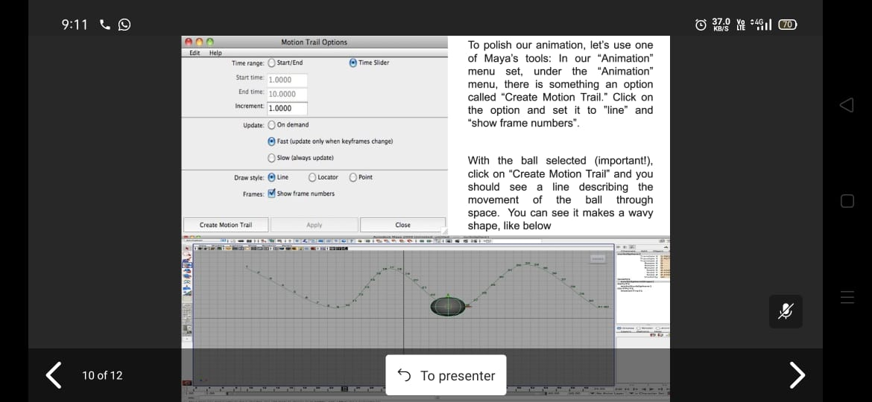

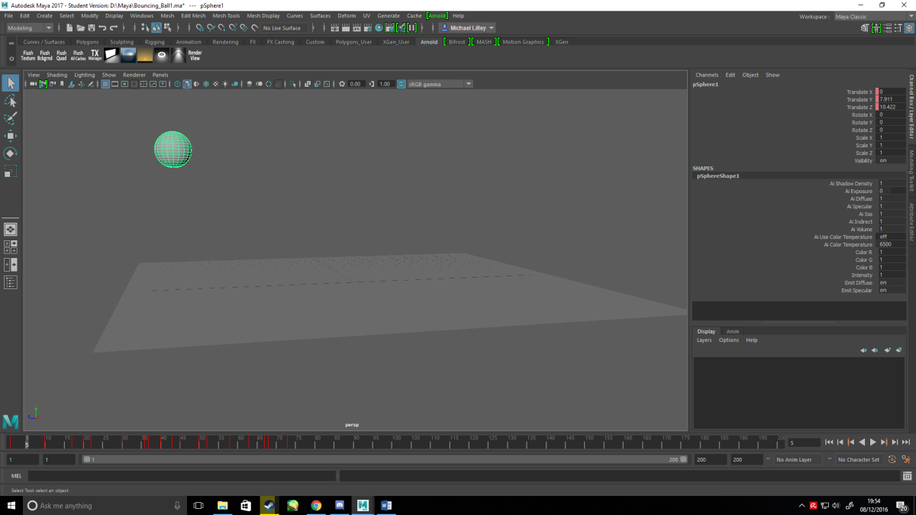

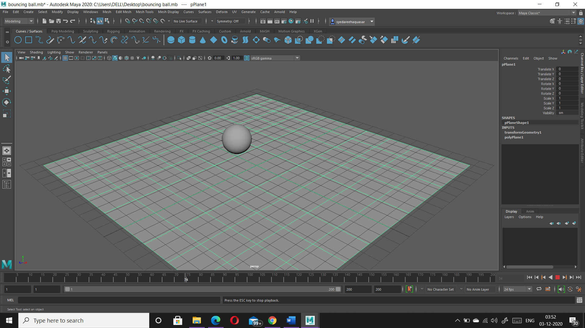**Animation Screenshots**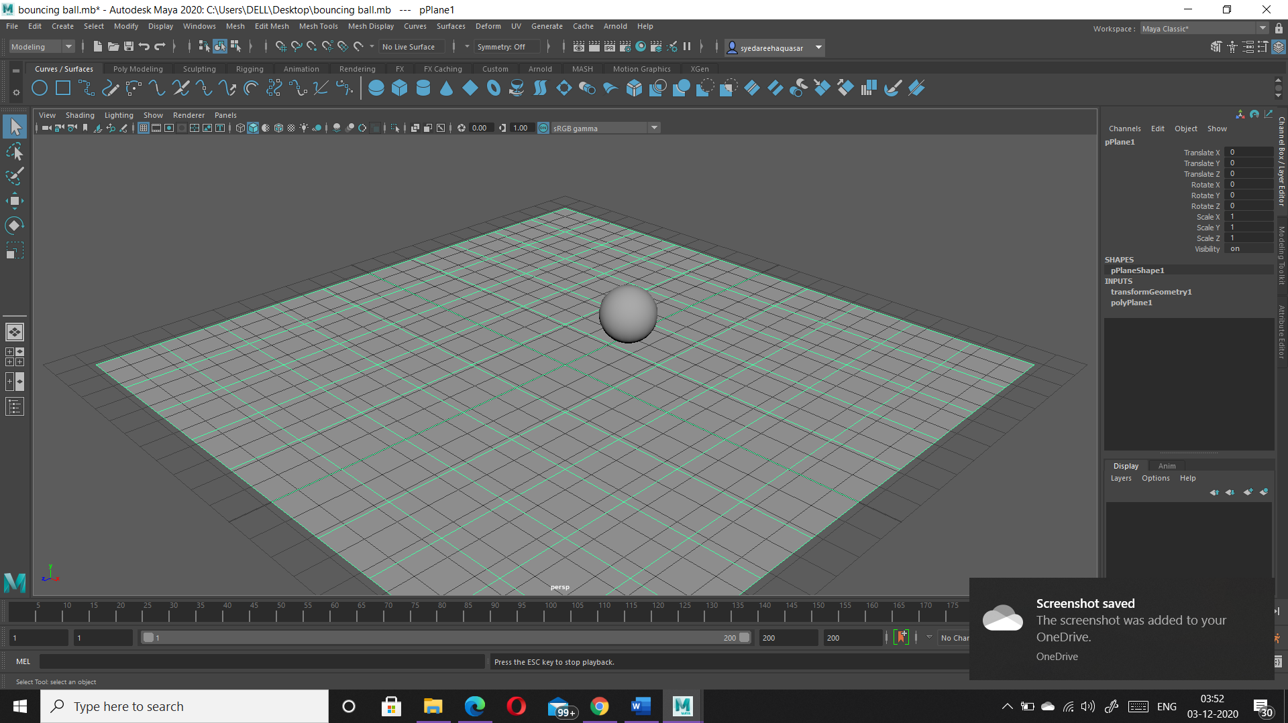

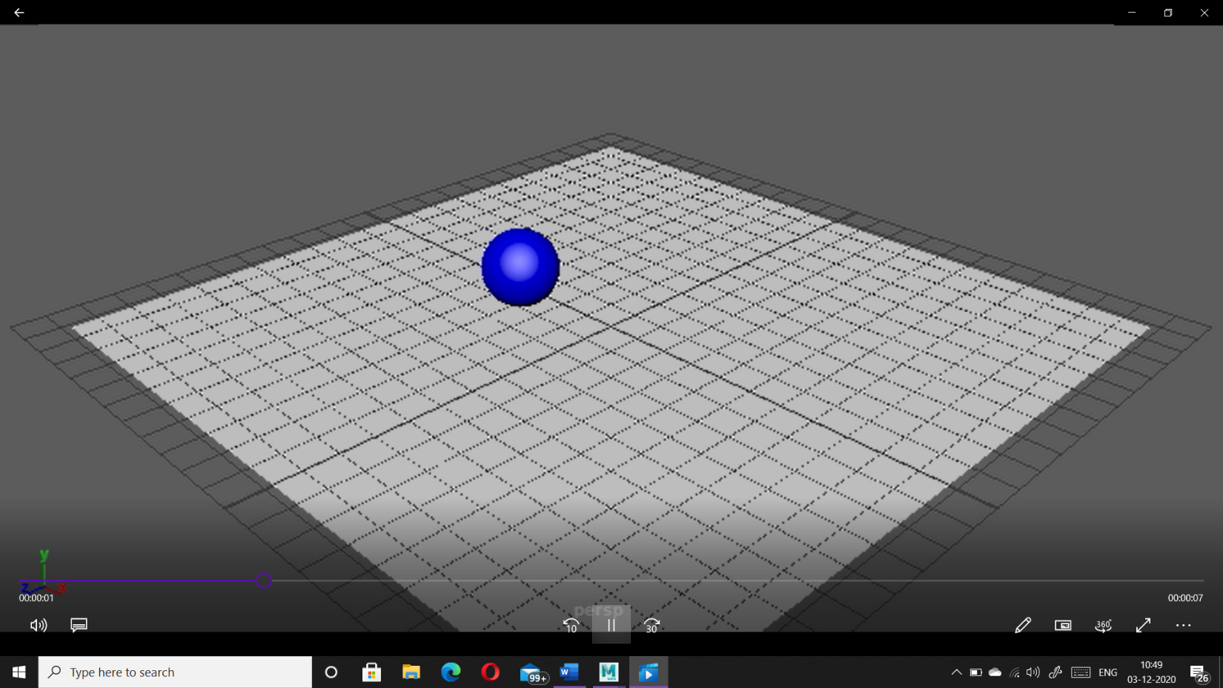

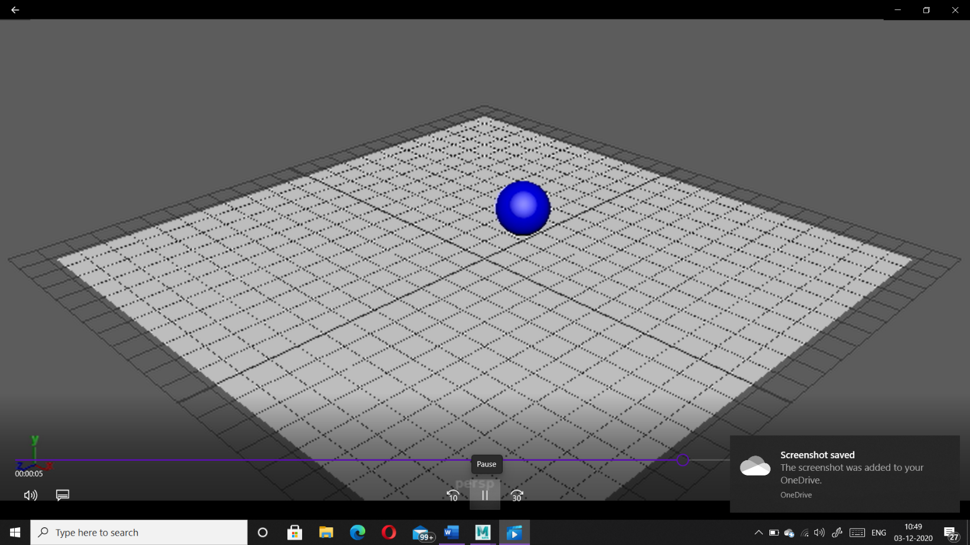

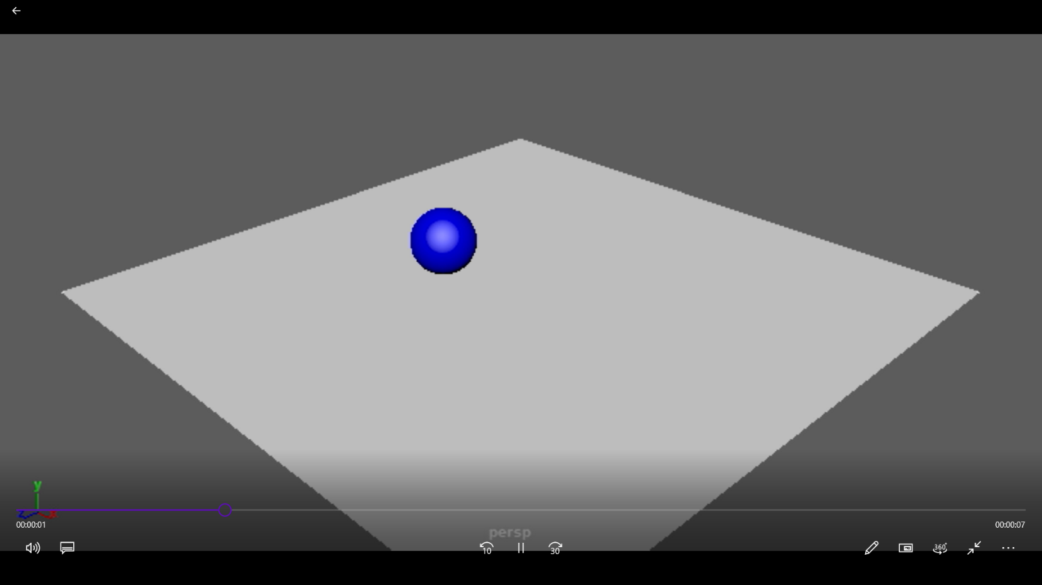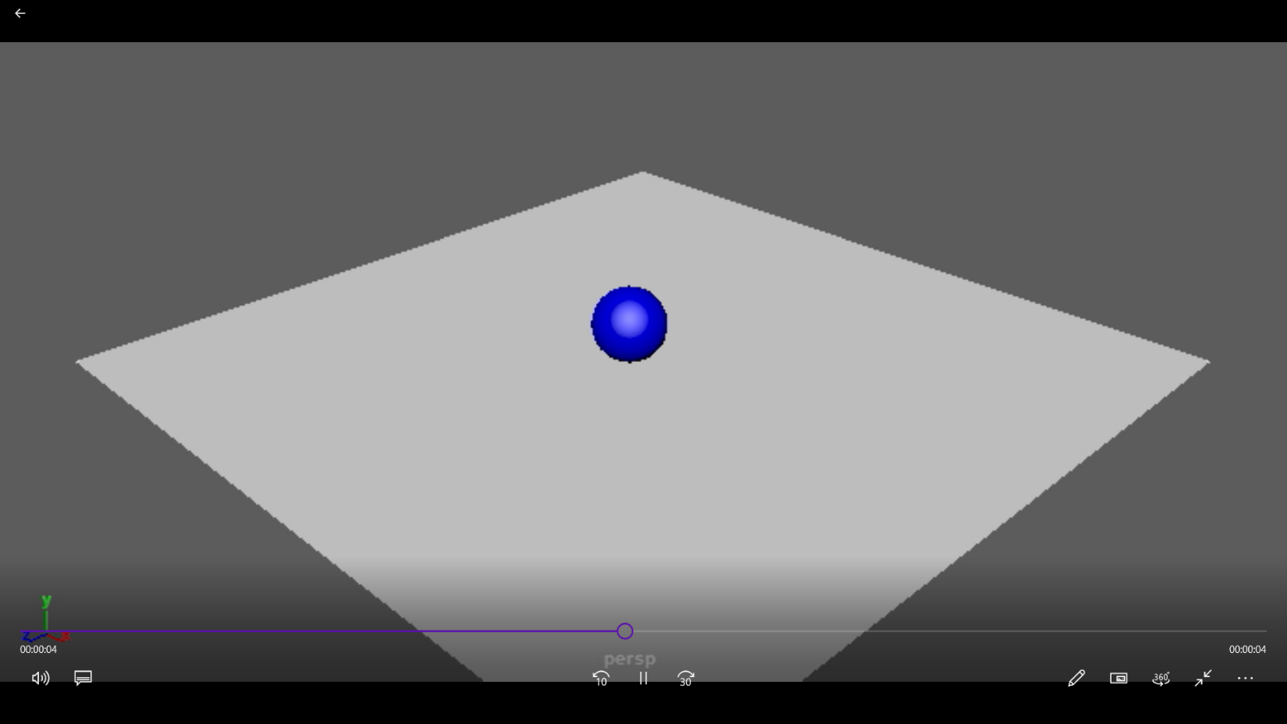

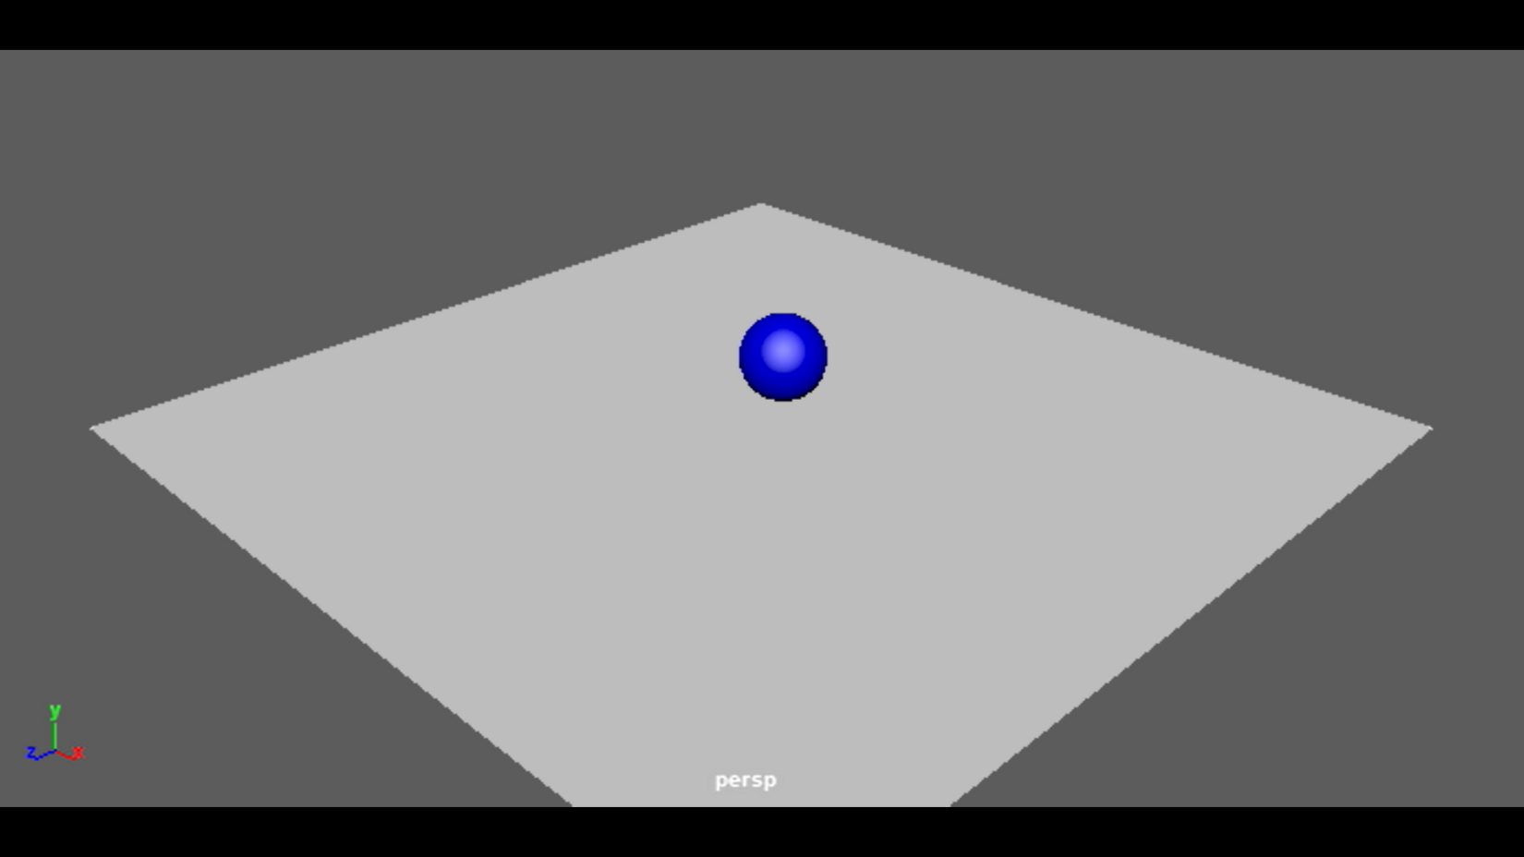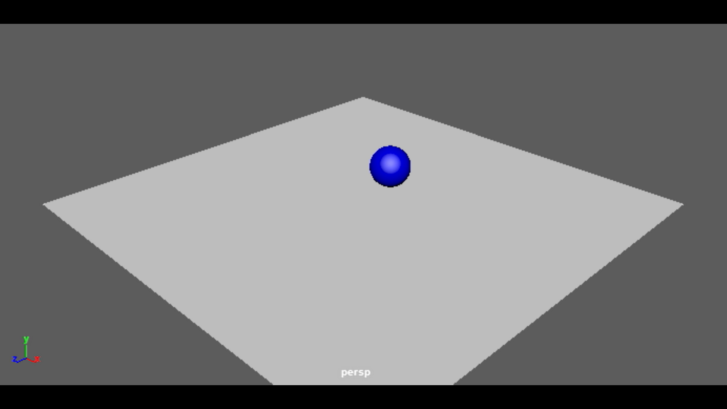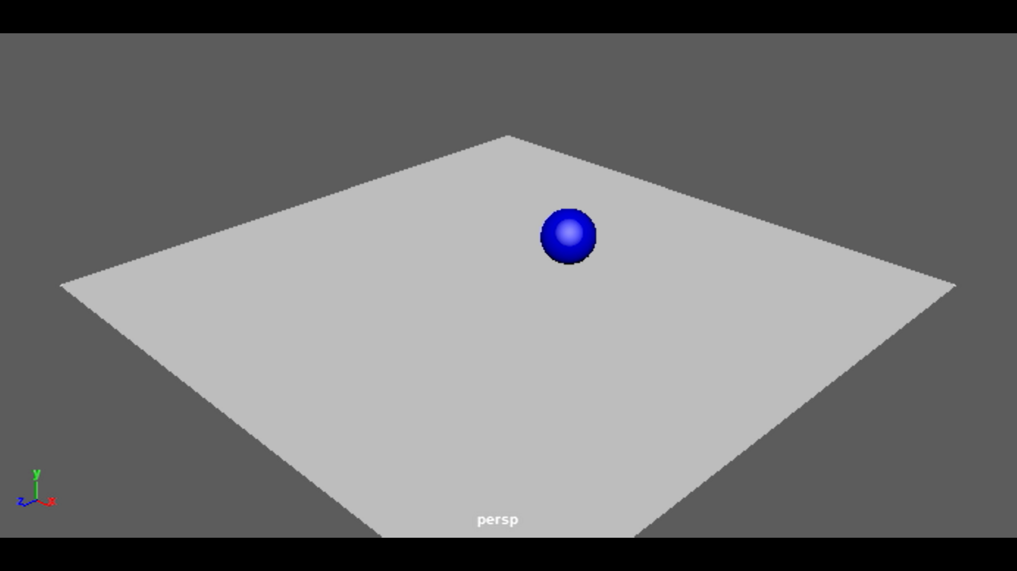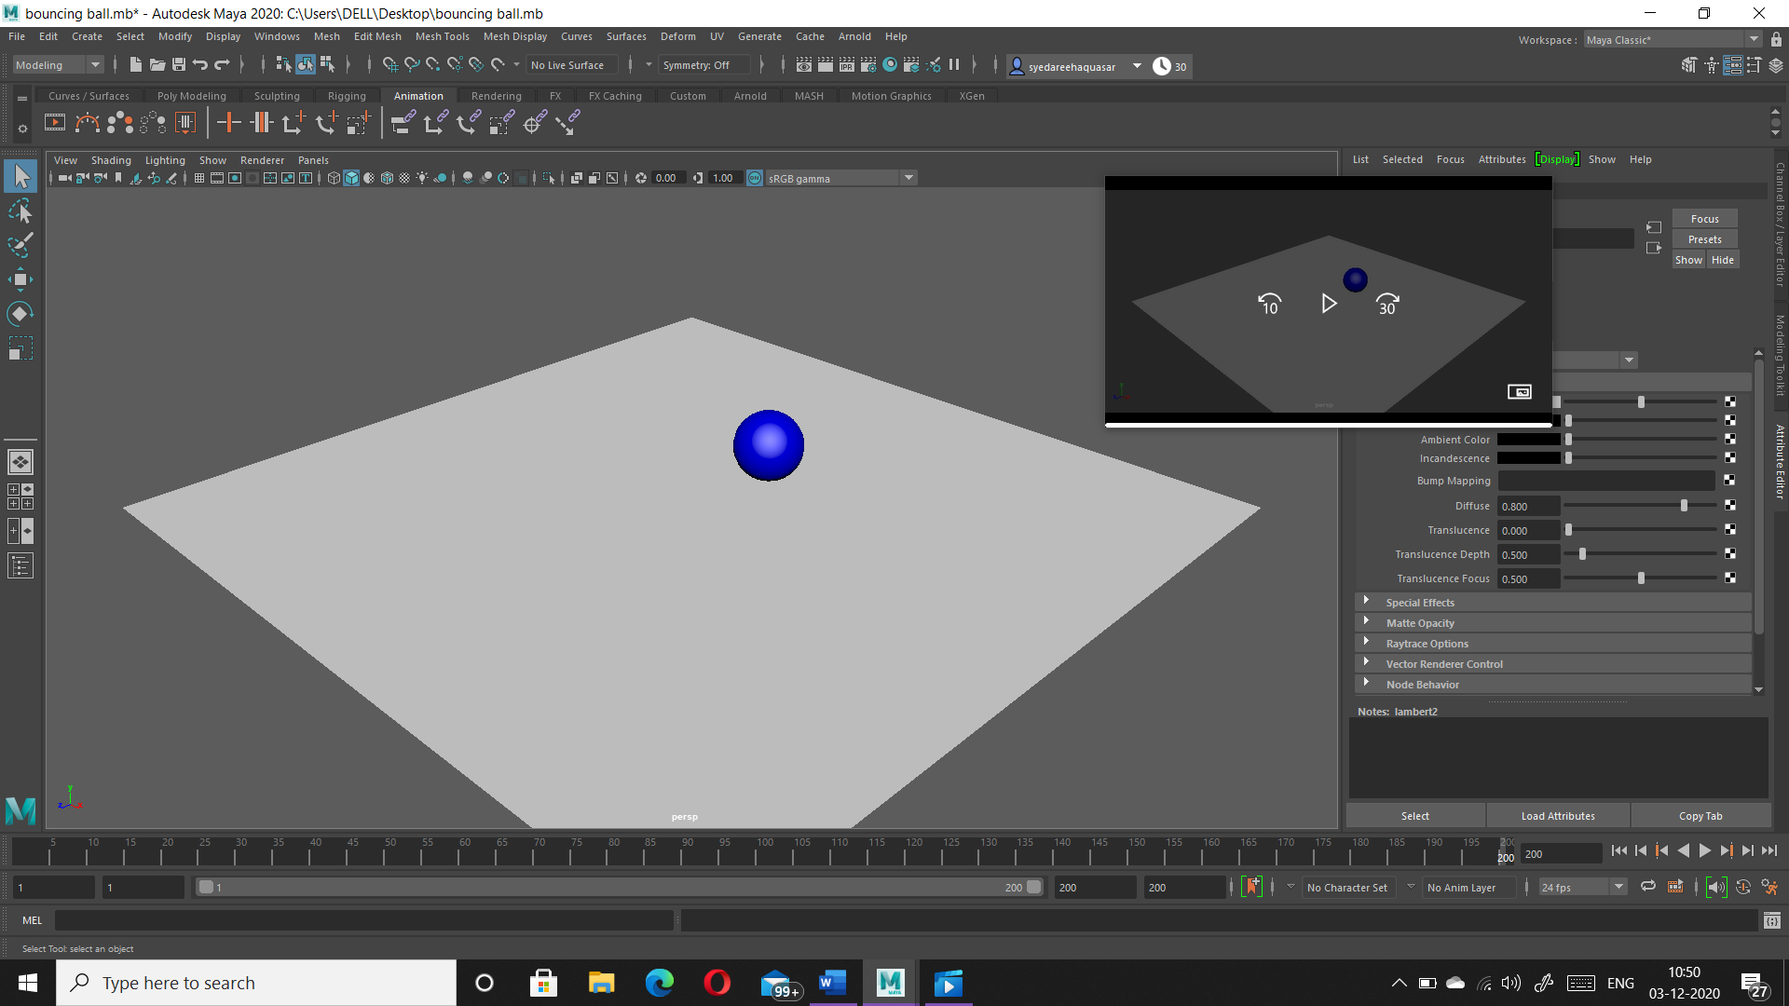

**VIVA-VOCE QUESTIONS**

**Q1. Short films that use stop motion techniques are what type animation?**

**a)** **Frame-based animation**

**b) HTML**

**c) Animation**

**d) Production**

Ans.

1. Frame-based animation

**Q2. ______ is the sequence of images displayed one after the other in a given time frame.**

**a) Translation**

**b) Animation**

**c) Ordering**

**d) Shearing**

Ans.

1. Ordering

**Q3 In which tab of properties window, frames per second, start time and end time is specified?**

**a) Image**

**b) Time**

**c) Duration**

**d) Animating**

Ans.

1. Time

**Q4. A video consists of a sequence of**

**a) Signals**

**b) Frames**

**c) Packets**

**d) Slots**

Ans.

b) Frames

**Q5. A ______ is a frame in which a changes to an object's properties are defined.**

**a) Multiframe**

**b) single frame**

**c) keyframe**

**d) userframe**

Ans.

1. KeyFrame